7PAM2000 APPLIED DATA SCIENCE 1

Assignment 1: Visualisation

Contents

Data Source Link 2

Visualization No. 1 -Line Plot 2

Visualization No. 2 -Pie Chart 3

Visualization No. 3 –Scatter Plot 4

Visualization No. 4 –Scatter Plot 5

# Data Source Link

<https://dataworks.calderdale.gov.uk/download/crime-and-safety-data/f7ecbd13-2f61-4f79-ad3b-f95922862699/Calderdale%2520Recorded%2520Crime%25202015-16%2520to%25202019-20.csv>

# Data visualization using line plot

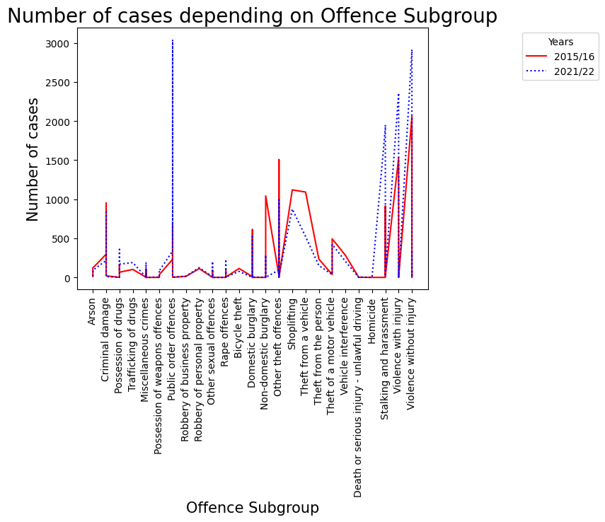

Figure 1 Line Chart

The visualization of data is expressed in Line Plot form; the data is of the “Number of Cases” depending on the “Offence Subgroup”. The offence subgroup that is the x-axis consists of the list of all the offences such as criminal damage, Rape offences, Trafficking of drugs, violence with and without injuries, Domestic Burglary, etc., and the y-axis consists of the number of cases recorded. The red line is to represent the data from the year 2015/16 and the blue dashed line is to represent the data for 2021/22. By observing the graph, it can be concluded that in 2015-16 the highest no. of cases was of violence without injury and this no. of cases for the same offence increased in 2021-22. But the highest no. of cases in 2021-22 are for public order offences.

# Data visualization using pie chart

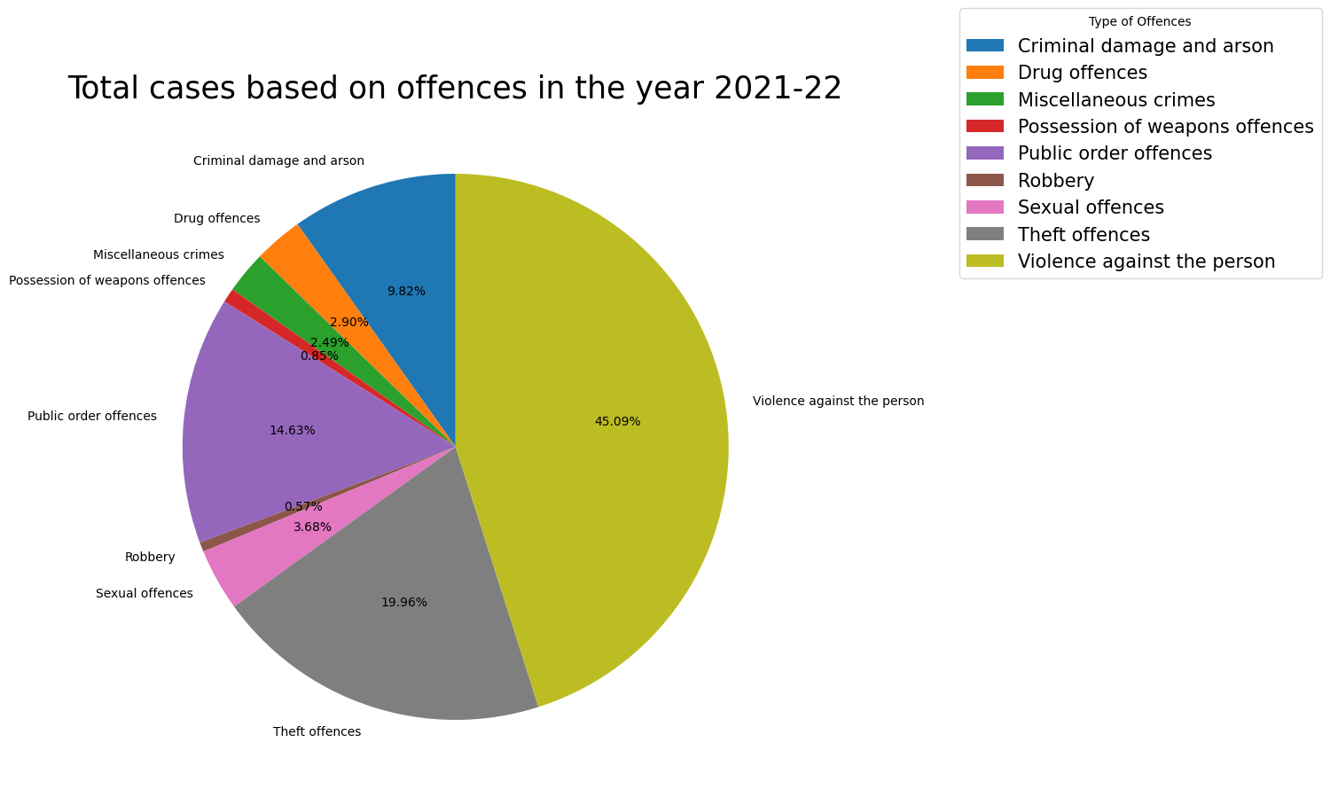

Figure Pie Chart

Now for this visualization no. 2 here pie chart is used for the data visualization. The same dataset of the no. of cases based on the type of offence in 2021-22 is visualized through the pie chart. As is clearly observed through the pie chart is that the no. of cases of violence against a person is maximum with 45.09% of total cases. Then in second place, is the no. of cases of Theft offences with 19.96% of the total cases in the year 2021-22. The lowest no. of cases are for Robbery with 0.57% of the total cases.

# Data visualization using scatter plot

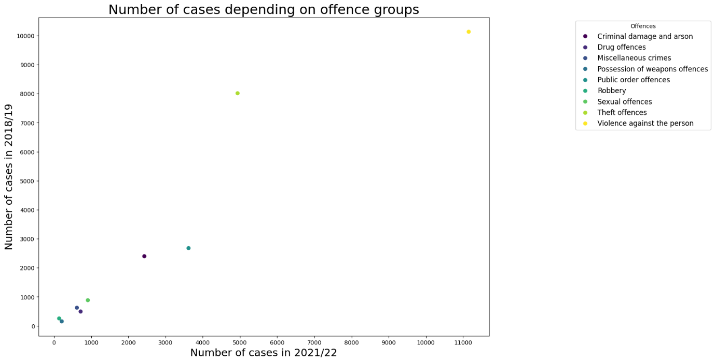

Figure Scatter Plot 1

The Scatter Plot is used as the third Visualization method, the same dataset is visualized through the Scatter plot. In this scatter plot the number of cases depending on the offence groups in the year 2018-19 and in the year 2021-22 is shown. As it is observed through the scatter plot the no. of cases of violence against the person is more than 10,000 in 2018-19 and similarly, it is still more than 10,000 in the year 2021-22.

# Data visualization using scatter plot

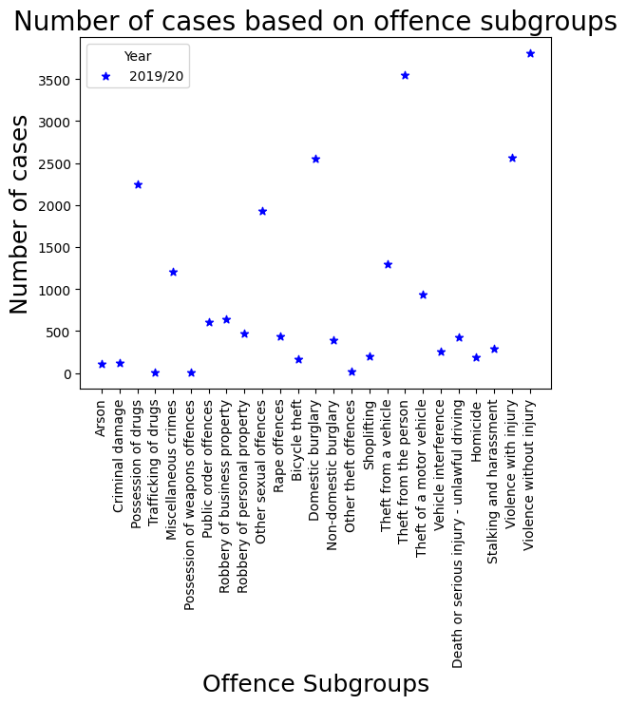

Figure Scatter Plot 2

Here, in the 4th type of visualization, a scatter plot is used to visualize the data of no. of cases based on the offence subgroups for the year 2019-20. The X-axis of the plot contains the list of names of all the offence sub-groups. And the y-axis is showing the number of cases. According to the visualization done and shown in the above scatter plot, it can be clearly observed that the highest no. of cases is of violence without injury which is more than 3500 no. of cases.